

UNIVERSITY OF AZAD JAMMU AND KASHMIR

SUBMITTED BY:-
UMAIR KHAN IKRAM

SUBMITTED TO:-
Engr.Sidra Rafique

COURSE CODE:-
ET-3106

SUBJECT:-
IMAGE PROCSSING TECHNOLOGY

SEMESTER:-
5TH

DEPARTMENT:-
DEPARTMENT OF SOFTWARE ENGINEERING

Task 1
Code:
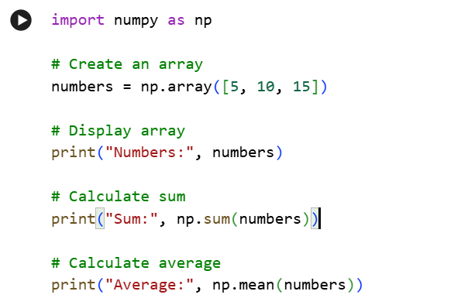
Output:

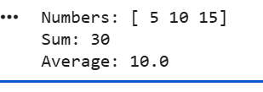

Task 2
Code:

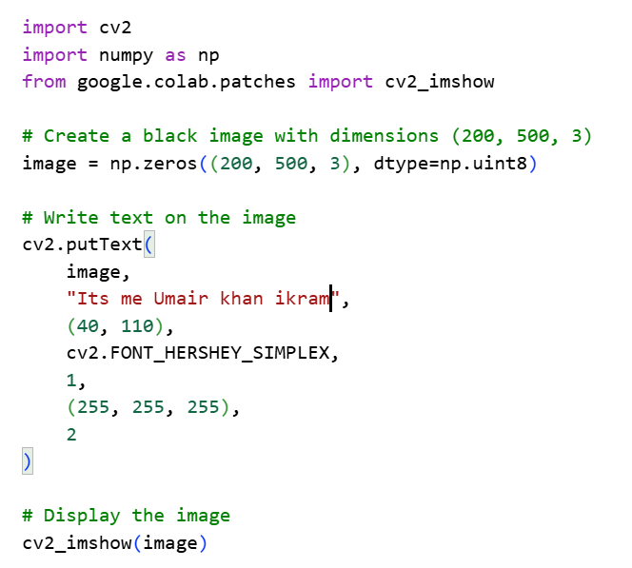

Output:


Task 3
Code:

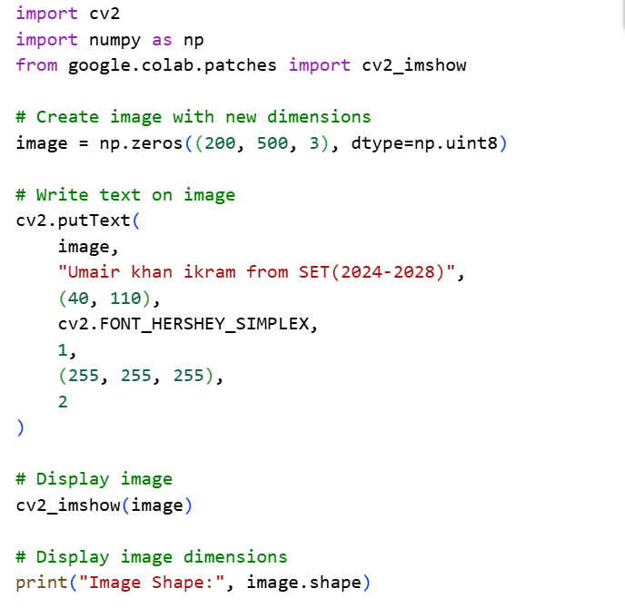
Output:

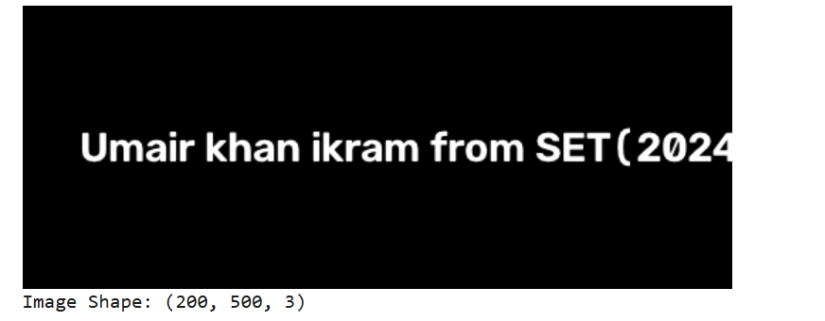
Task 4
Code:

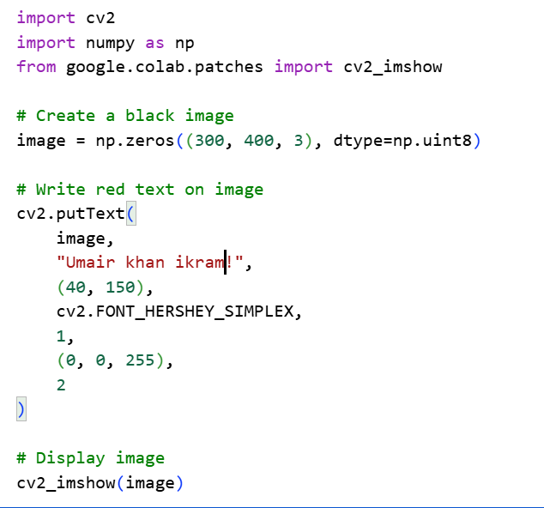
Output:



